REACT HANDS ON 12

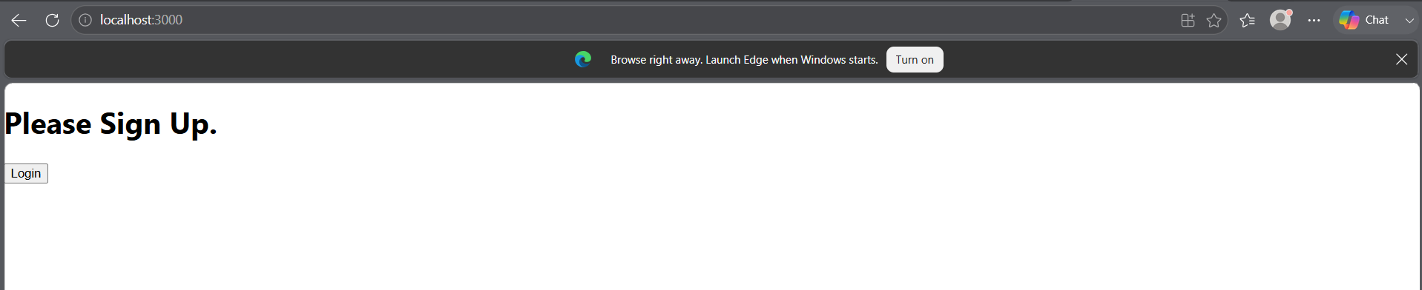

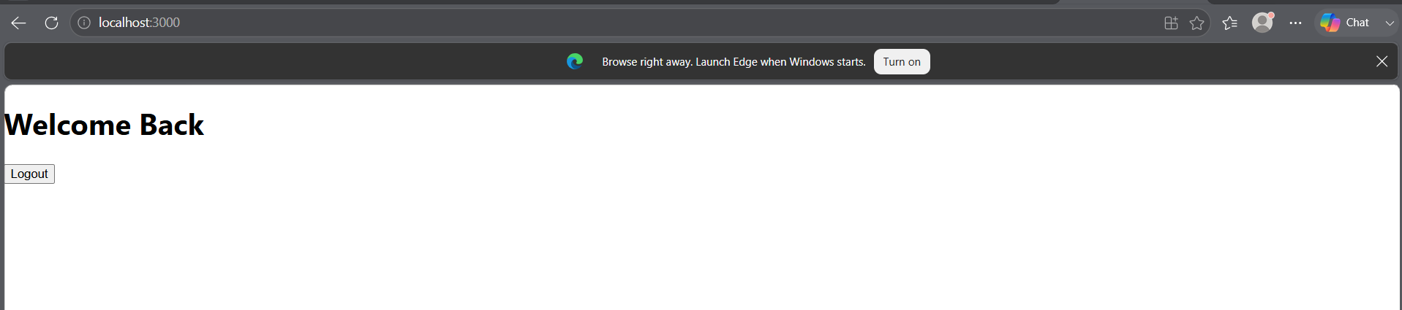

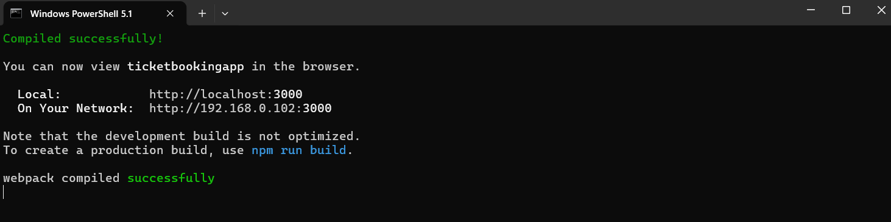

APP.JS
import React, { useState } from 'react';

function LoginButton(props) {
return (
<button onClick={props.onClick}>
Login
</button>
);
}

function LogoutButton(props) {
return (
<button onClick={props.onClick}>
Logout
</button>
);
}

function UserGreeting() {
return (
<h1>Welcome Back</h1>
);
}

function GuestGreeting() {
return (
<h1>Please Sign Up.</h1>
);
}

function Greeting(props) {
const isLoggedIn = props.isLoggedIn;

if (isLoggedIn) {
return <UserGreeting />;
}

return <GuestGreeting />;
}

function App() {

const [isLoggedIn, setIsLoggedIn] = useState(false);

const handleLoginClick = () => {
setIsLoggedIn(true);
};

const handleLogoutClick = () => {
setIsLoggedIn(false);
};

let button;

if (isLoggedIn) {
button = (
<LogoutButton onClick={handleLogoutClick} />
);
} else {
button = (
<LoginButton onClick={handleLoginClick} />
);
}

return (
<div>
<Greeting isLoggedIn={isLoggedIn} />
{button}
</div>
);
}

export default App;

